Hi Sunny –

Thanks for implementing all the changes! There was quite a bit and I appreciate the quick turnaround.

There were a few more things I wanted to run by you and I have outlined them below:

1 – S&P 500 graph

For some reason the S&P 500 data series is scrunched up towards the top of the chart regardless of where the zoom slider is position. Is it possible to adjust this so that the S&P 500 data series adjusts to the full size of the chart just like the other two data series?

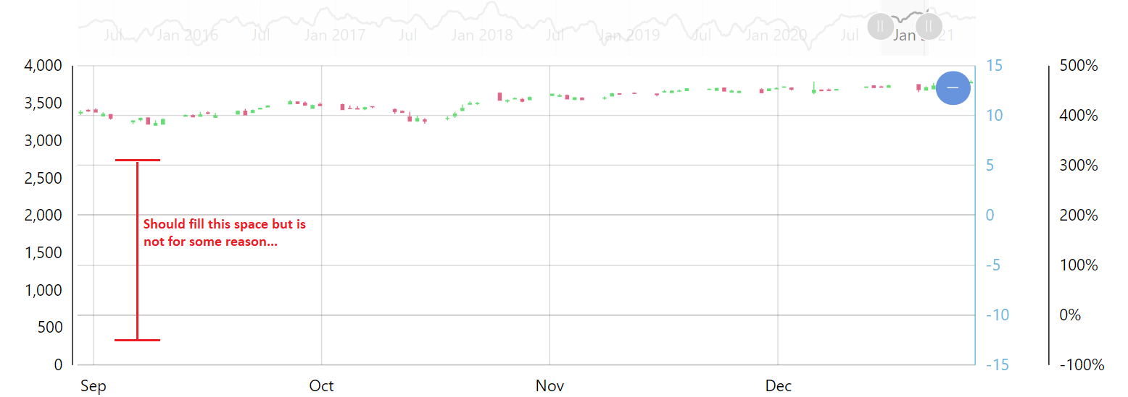

2 - Gap between axes

There still seems to be a large gap between the axes at positions 1 and 2. Please see the below screenshots. The first one is of our chart and there is a large gap between the axes. I thought that removing the label of each axis would automatically make them closer together. That’s what I was hoping for at least. The second screenshot shows the example from amcharts where their two axes are closer together. Do you mind trying to adjust our axes so that they are closer together? My goal was to increase the size of the chart area on the screen by compressing the space the axes takes up.

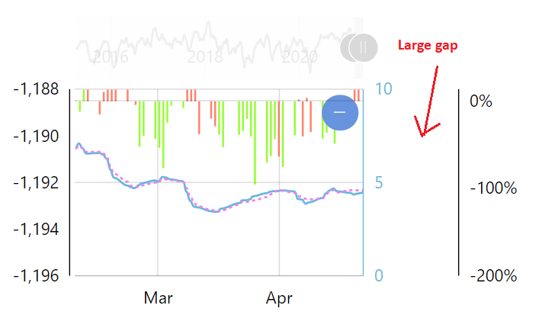

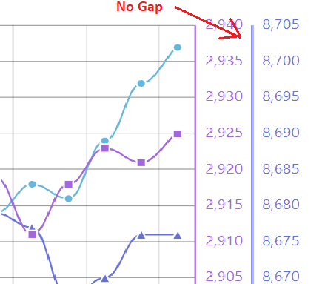

Modifications to Options Accuracy chart…

I forgot to include these in the original writeup sent over yesterday – apologies. But can the following modifications please be made?

1 – Can the legend be moved to under the chart (just how we have done for the other charts)?

2 – Can the “Annotation” data series be made to show upon initial loading of the chart by default?